|  |  |  |  |  |
| --- | --- | --- | --- | --- |
|  |  |  |  | Ansell Protective Solutions AB  Tel. +46 10 205 1800  [order.protective@ansell.com](mailto:order.protective@ansell.com) |

**Customer Declaration of Returns Safety**

**Date: _____________ Customer ref. ______________ Re: Return of products to Ansell**

Please fill in as required below and sign accordingly, in order to declare that **the products are safe to be returned** to Ansell and handled as needed for repair and/or testing.

|  |  |  |  |  |
| --- | --- | --- | --- | --- |
| Customer: |  |  | DELIVER TO: | Ansell Protective Solutions Lithuania |
| Address: |  |  | Address: | Pramones str. 5K |
|  |  | 72328 Taurage |
|  |  | Lithuania |
|  |  | Phone contact: | Logistics Manager:  +370 62092125 |
| Phone contact: |  |  |
| Email contact: |  |  | Email contact: | warehouse.apslit@ansell.com |

I hereby declare that the items to be returned to Ansell are **safe to be handled** as needed for repair and/or testing. Either no contact with any chemicals has occurred during the lifetime of the products or appropriate decontamination has been provided in case of contact with chemicals (please mark in the table below).

|  |  |  |  |  |  |
| --- | --- | --- | --- | --- | --- |
| **Suit** | **Serial No.** | **Service or Quality Complaint?** | **Never used** | **Used and deconta-minated** | **Remarks about what needs to be repaired with marks on the shapes below** |
| 1 |  | - Service  - Complaint |  |  |  |
| 2 |  | - Service  - Complaint |  |  |  |
| 3 |  | - Service  - Complaint |  |  |  |

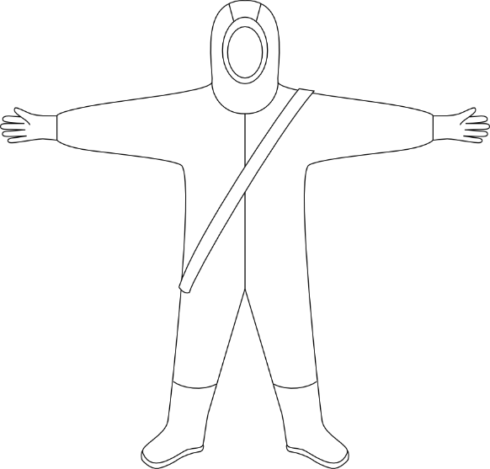

|  |  |  |  |  |
| --- | --- | --- | --- | --- |
|  |  |  |  |  |
| Signature |  | Name, Surname |  | Title |